# 1.1 Project Objectives (Background)

The customer Mr. Tan is a 63-year-old man who has recently retired from the workforce. Currently, Mr. Tan is living alone in a 5-room flat at Bukit Merah. He mentioned that he is aging, and no longer has the energy to spend cleaning up the entire house alone. As such, he wishes to sell his 5-room flat and purchase a smaller flat of at most 80 square meters where he need not spend so much time cleaning the house. Mr. Tan added that he wanted a house in the West so that his son living in Jurong East need not waste time traveling to visit him every week.

Summary:

Customer Name: John Tan

Requests: Recommend a suitable price to sell his 5-room flat at Bukit Merah.

: Recommend a smaller flat to buy in the West.

Concerns: Distance from Jurong East not too far

: Area of house less than 80 square meters

Assumptions: Mr Tan may live up to 120 years old

: Mr Tan may not know the reasons for the difference in resale prices of flats

# 1.2 Project Objectives (Exploratory Questions)

Location Analysis

* Which location is nearer to Jurong East?
* What is the average cost of flats in the various towns in West Singapore?
* What is the average cost of flats in Bukit Merah Town?

Product Analysis

* Which flat type cost less?
* Is there a relation between flat type and floor area?

Price Analysis

* How will the flat type affect the resale prices?
* How will the flat age affect the resale prices?
* How will the floor area affect the resale prices?
* How will the flat storey affect the resale prices?

Time analysis

* Is there a relation between months and resale prices?
* Which month selling a flat would generate the most sale?
* Which month buying a flat would cost the least?

# Data Preparation

Step 1: Create a new database named “ResaleFlatPrices” using SQL

Step 2: Import all the csv files into the “ResaleFlatPrices” database. When importing files that contain data for year 2015 onwards, ignore column “remaining_lease” (Not all files contain the column remaining lease. Ignoring this column standardises the headers for all files.).

Step 3: Capitalise “flat_model” column. (This is because, some data under flat_model is capitalised while some are small letters. Performing this action standardises the flat model data.)

: Remove the “-” for the “MULTI-GENERATION” under “flat_type”. (This is because, the multi generation data exists as “MULTI GENERATION” and “MULTI-GENERATION” under flat type. Performing this action standardises the flat type data.)

Now the displayed result is consistent throughout the whole database. However, it still contains duplicates.

Step 4: Save the displayed results as a new CSV file.

Step 5: Remove duplicates that exist within the data. (The data contains 1935 duplicate data. Removing them prevents me from double counting the data.)

Now the data is clean and ready to be used in tableau.

# Exploratory Data Analysis and Visualisation

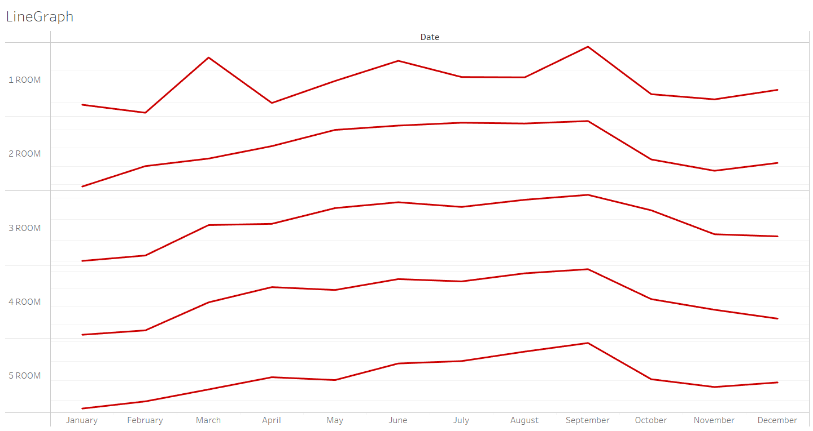

The visual above shows a general trend of the average resale price throughout the different months. This allows me to gain insights into the patterns for resale prices of the different flat types. As such, I can then know the month that resale prices peak, and the month it plunges, allowing me to provide better suggestions for my customer. Furthermore, this is important to show my customer Mr. Tan as he may not know the trends of resale prices over the months. Creating this visual helps me to answer the exploratory questions under Time analysis (Is there a relation between months and resale prices? Which month selling a flat would generate the most sale? Which month buying a flat would cost the least?)

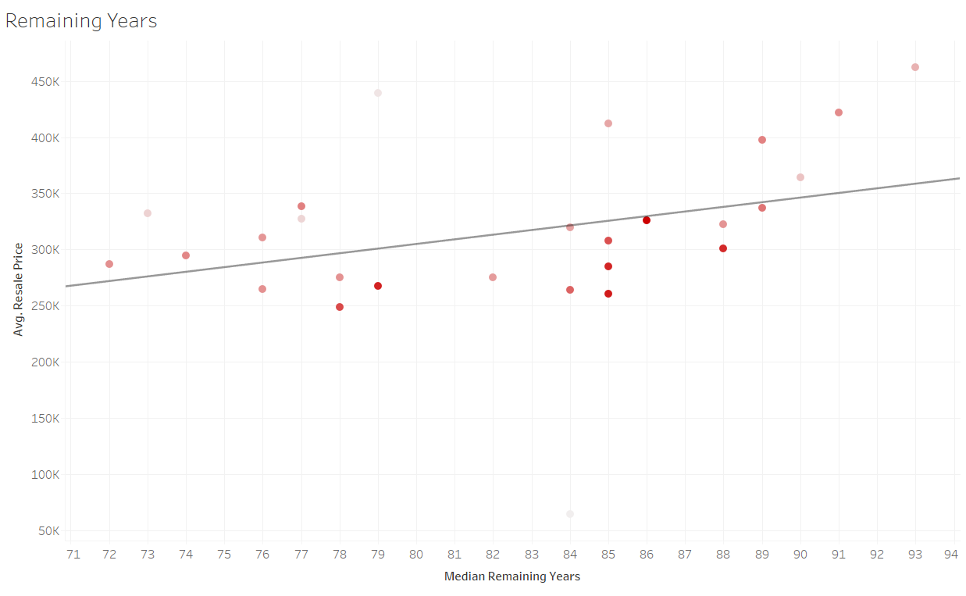

The visual above shows a predictive trend of the average resale price against the remaining years of flat. This allows me to gain insights into the pattern for resale prices as flats age. With that, I can say that as the flat ages, the resale price decreases. Furthermore, this is important to show my customer, Mr. Tan, as it is one of the fundamentals one should know before buying or selling a flat. Creating this visual helps me to answer the exploratory question “How will the flat age affect the resale prices?”

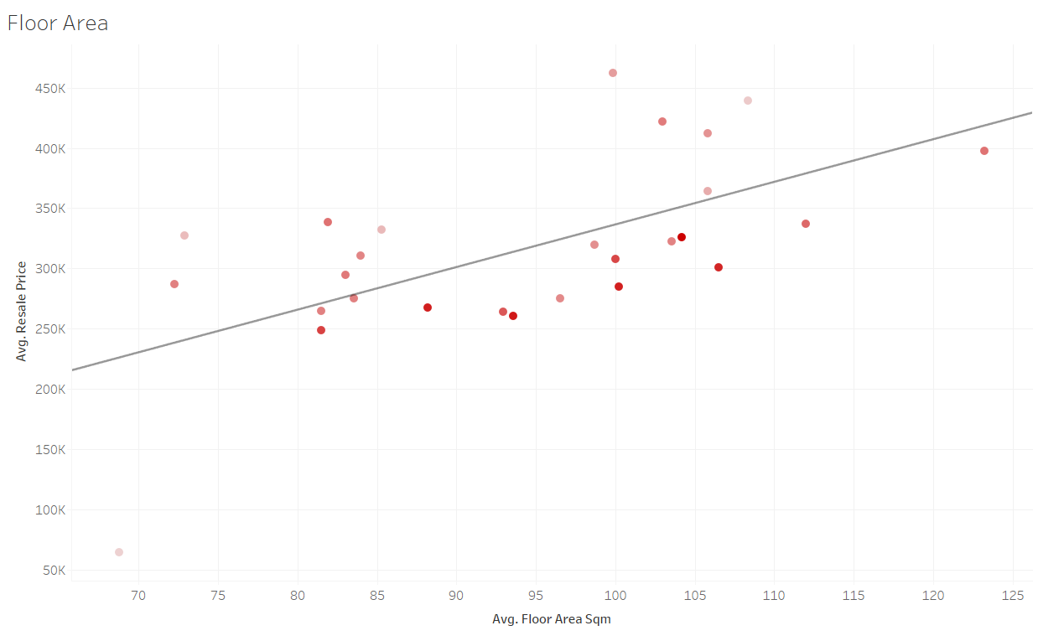

The visual above shows a predictive trend of the average resale price against the floor area of flats. This allows me to gain insights into the relationship between resale prices and floor area. With that, I can say that as the floor area increases, the resale price increases. Furthermore, this is important to show my customer, Mr. Tan, as it is one of the fundamentals one should know before buying or selling a flat. Creating this visual helps me to answer the exploratory question “How will the floor area affect the resale prices?”

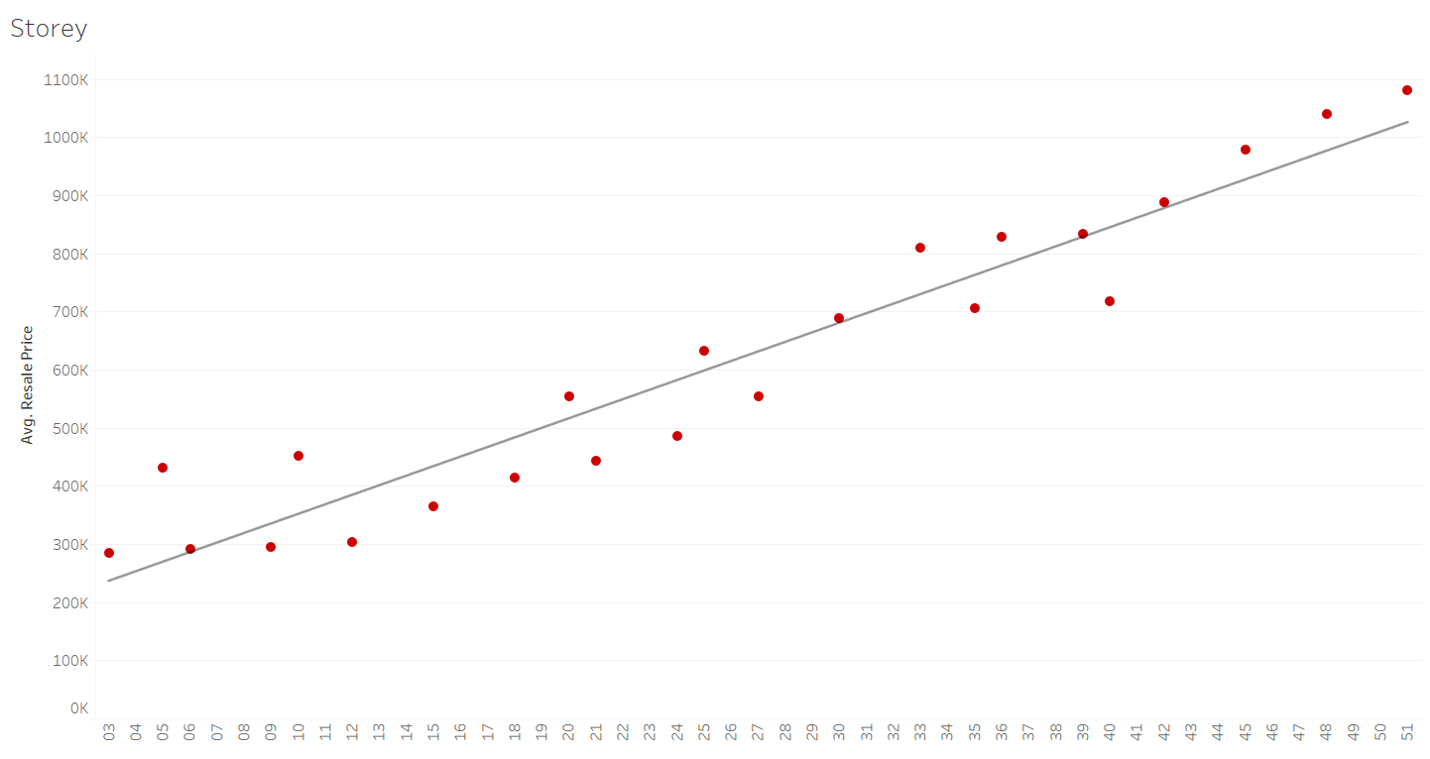

The visual above shows a predictive trend of the average resale price against the storey of the flat. This allows me to gain insights into the pattern between resale prices and the storey of flat. With that, I can say that the higher the storey, the higher the resale price. Furthermore, this is important to show my customer, Mr. Tan, as it is one of the fundamentals one should know before buying or selling a flat. Creating this visual helps me to answer the exploratory question “How will the flat storey affect the resale prices?”

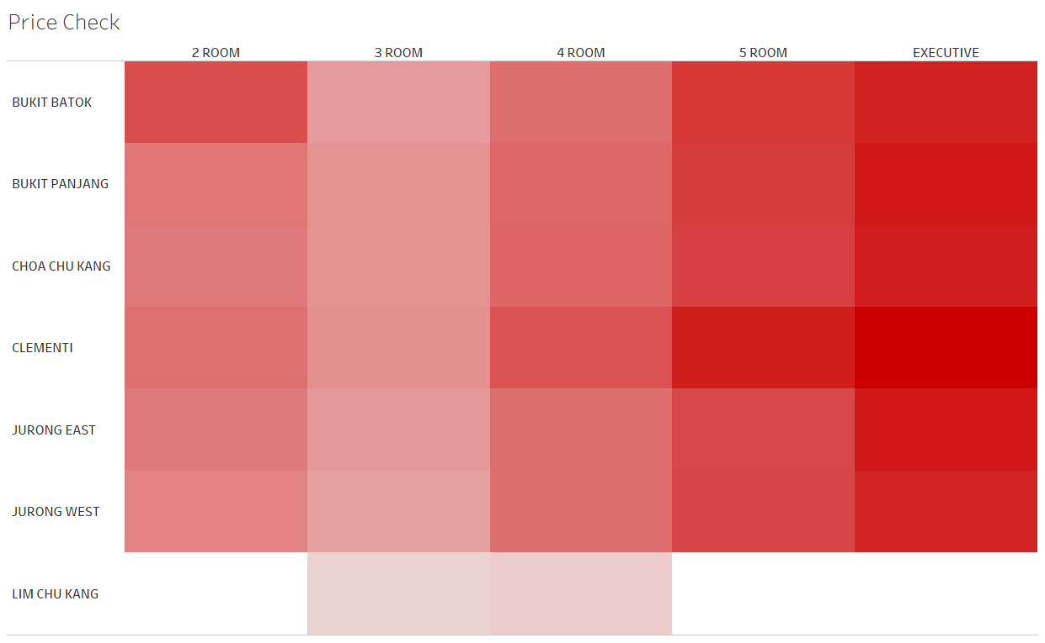

The visual above shows a pattern of the average resale price for the different flat types in the western region. The colour intensity represents the resale prices. The higher the resale price, the darker the shade of red. This allows me to identify the concentration in the diagram and understand how resale prices of flat varies with flat type and town. Furthermore, this is important to show my customer, Mr. Tan, as it is a key consideration one should know before purchasing a flat. Creating this visual helps me to answer the exploratory question “What is the average cost of flats in the various towns in West Singapore?"

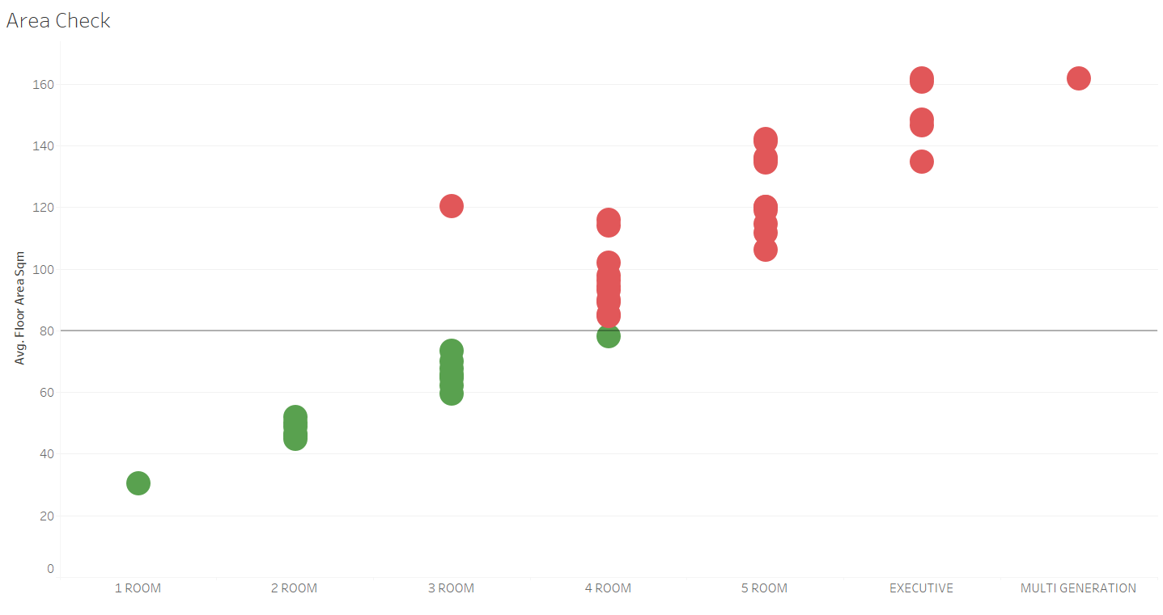

The visual above checks the average floor area of the different flat types. This allows me to identify the flat types that meet my customer's request, allowing me to provide him with better suggestions on which flat type to purchase. Furthermore, this is important to show my customer, Mr. Tan, as it is one of the concerns, he voiced out earlier. Creating this visual helps me to answer the exploratory question “Is there a relation between flat type and floor area?”

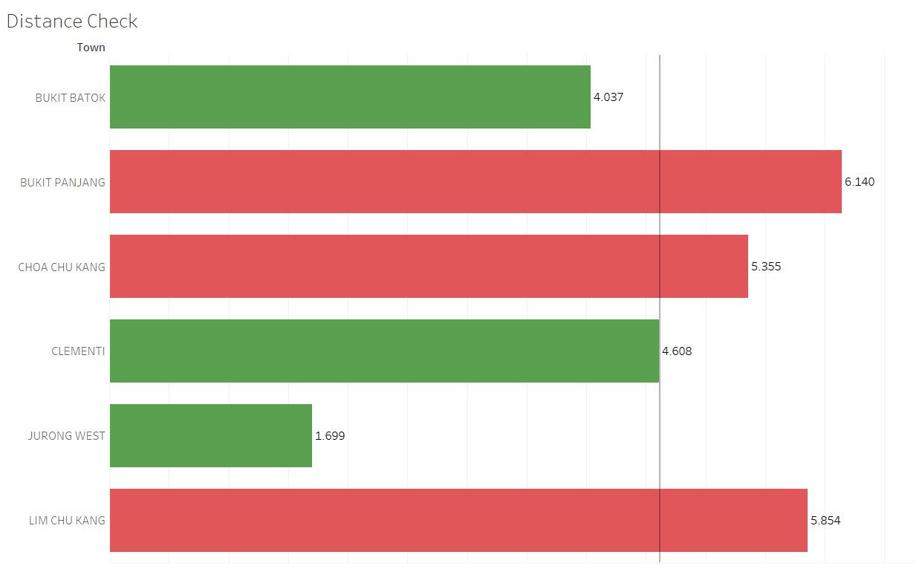

The visual above checks the average distance of the town from Jurong East. This allows me to identify the towns that are more suited for my customer, allowing me to provide him with better suggestions on which town to purchase. Furthermore, this is important to show my customer, Mr. Tan, as it is one of the concerns, he voiced out earlier. Creating this visual helps me to answer the exploratory question “Which location is nearer to Jurong East?”

The visual above shows **hierarchical data of** the prices of 2 and 3-room flats in towns Jurong West, Bukit Batok, Clementi, and Jurong East. The colour intensity represents the resale prices. The higher the resale price, the darker the shade of red. This allows me to compare prices and identify the towns and streets that are more suited for my customer, allowing me to provide him with better suggestions on where he should purchase his flat. Creating this visual helps me to narrow down the towns and streets that I would recommend to him.

The map above shows **distinct** prices of 2 and 3-room flats in towns Jurong West, Bukit Batok, Clementi, and Jurong East. The colour intensity represents the resale prices. The higher the resale price, the darker the shade of red. This is **narrowed further till the block number**. This allows me to compare prices and identify the blocks that are more suited for my customer, allowing me to provide him with better suggestions on where he should purchase his flat. Creating this visual helps me to narrow down the blocks that I would recommend to him.

The map above shows **distinct**prices of 5-room flats in the town of Bukit Merah. The colour intensity represents the number of flats sold, while the size of the circle represents the resale prices. This is **narrowed further till the block number.** This allows me to compare prices and the number of flats sold for each block, allowing me to provide him with better suggestions on the price he can sell his flat. Creating this visual helps me to answer the exploratory question “What is the average cost of flats in Bukit Merah Town?”

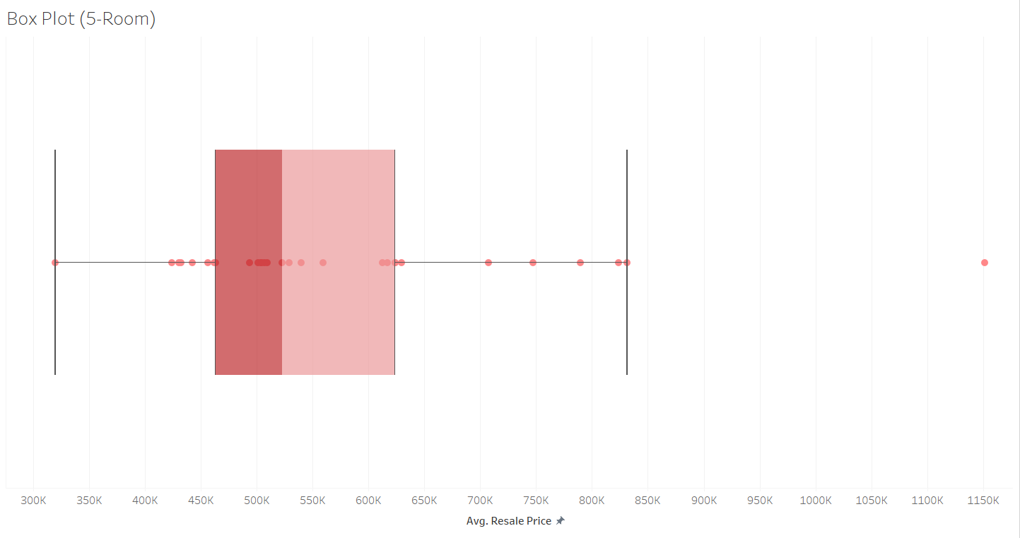

The visual above shows a distribution of the average resale price of 5-room flats in Bukit Merah town. This allows me to identify the distribution and the outliers in the diagram and understand how resale prices of flat varies for the 5-room flat in Bukit Merah. With that, I can make better suggestions for the price for Mr. Tan to sell his flat.

The visual above list the average resale prices of 5-room flats in Bukit Merah town in the last 5 years. This is to create an interactive visual for Mr. Tan to scroll and look through the specific blocks and know the resale prices of 5-room flats. With that, Mr. Tan can dive specifically into the street and block of his flat and determine the best price to sell it.

# Dashboard

The dashboard above displays the significant factors affecting resale prices. By starting with simple trends that affect the resale prices of flats, I can ease my customer into more complex visuals after. Furthermore, this allows me to be sure that my customer, Mr. Tan understands the fundamentals behind what affects the resale prices of flats. This is especially so with the assumption that Mr. Tan may not know the reasons for the difference in resale prices of flats. With that, it allows me to know the various trends and identify the flats that are more suited for my customer, providing him with better suggestions on where he should purchase a flat and the price to sell his 5-room flat in Bukit Merah.

The dashboard above displays the parameters based on the concerns (Distance from Jurong East not too far and the area of the house less than 80 square meters) of my customer, Mr. Tan. By doing so, I can confirm the requirements of my customer and assure him that flats recommended will be suitable. Furthermore, it allows me to narrow down to the specific flat types and towns when considering the flat recommendations for him. With that, I can provide him with better suggestions on where he should purchase his flat.

The dashboard above displays the flat recommendations after taking in Mr. Tan’s concerns (Distance from Jurong East not too far and the area of the house less than 80 square meters). This dashboard filters the flat types and towns, diving directly into the specific blocks to recommend to my customer. With that, I could compare the prices and better identify the towns, streets, and blocks that are most suited for my customer.

The dashboard above displays the suggestions for my customer, Mr. Tan of the price to sell his 5-room flat at Bukit Merah. The Map starts off by comparing prices and the number of flats sold for each street in Bukit Merah Town. Next, we have the boxplot which shows the distribution in which the price of flat ranges. Lastly, I allow my customer to filter according to the street name and know the average resale prices of flats that were sold in the past 5 years. With that, I can provide him with better suggestions on the price range to sell his flat.